Car or Cup?

In this project you will make a Scratch project that learns to sort photos.

You will train the computer to be able to sort a set of photos into two piles:

* one pile of photos of cars, and

* one pile of photos of cups



This project worksheet is licensed under a Creative Commons Attribution Non-Commercial Share-Alike License



http://creativecommons.org/licenses/by-nc-sa/4.0/

1. Go to <https://machinelearningforkids.co.uk/> in a web browser
2. Click on “**Get started**”
3. Click on “**Log In**” and type in your username and password  
   *If you don’t have a username, ask your teacher or group leader to create one for you.  
   If you can’t remember your username or password, ask your teacher or group leader to reset it for you.*
4. Click on “**Projects**” on the top menu bar
5. Click the **“+ Add a new project**” button.
6. Name your project “car or cup” and set it to learn how to recognise “**images**”.   
   Click the “**Create**” button  
   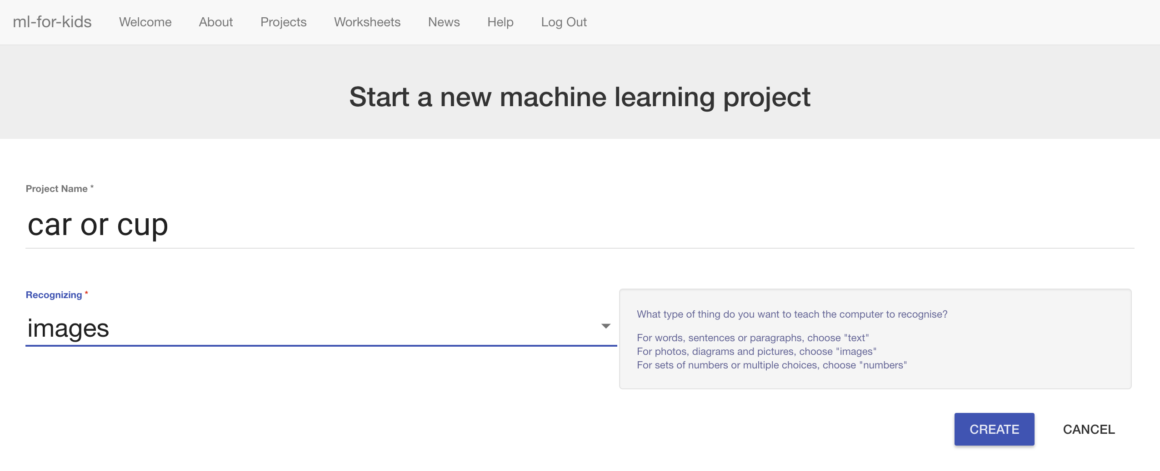
7. You should now see “**car or cup**” in the list of your projects.   
   Click on it.
8. Click the “**Train**” button to start collecting examples.  
   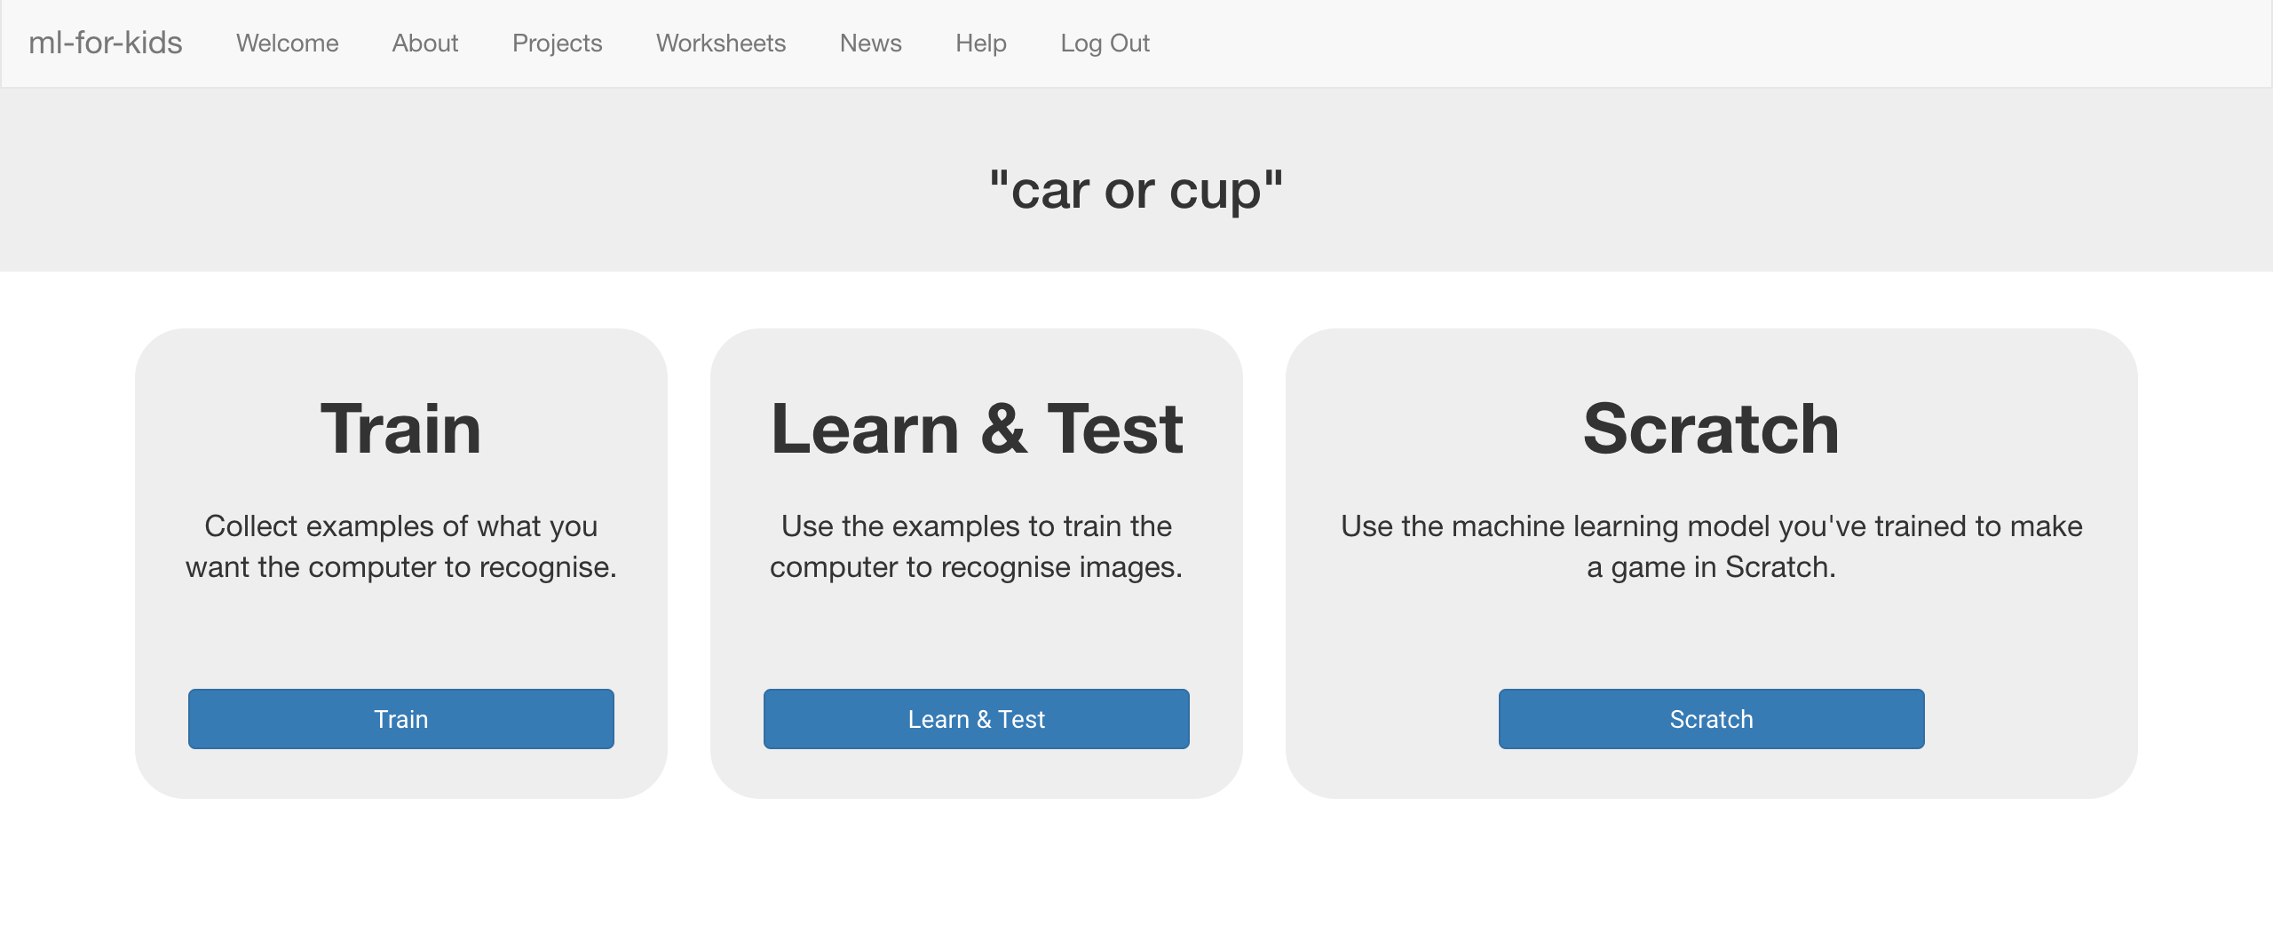

1. Click on **“+ Add new label**” and call it “car”.   
   Do that again, and create a second bucket called “cup”.  
   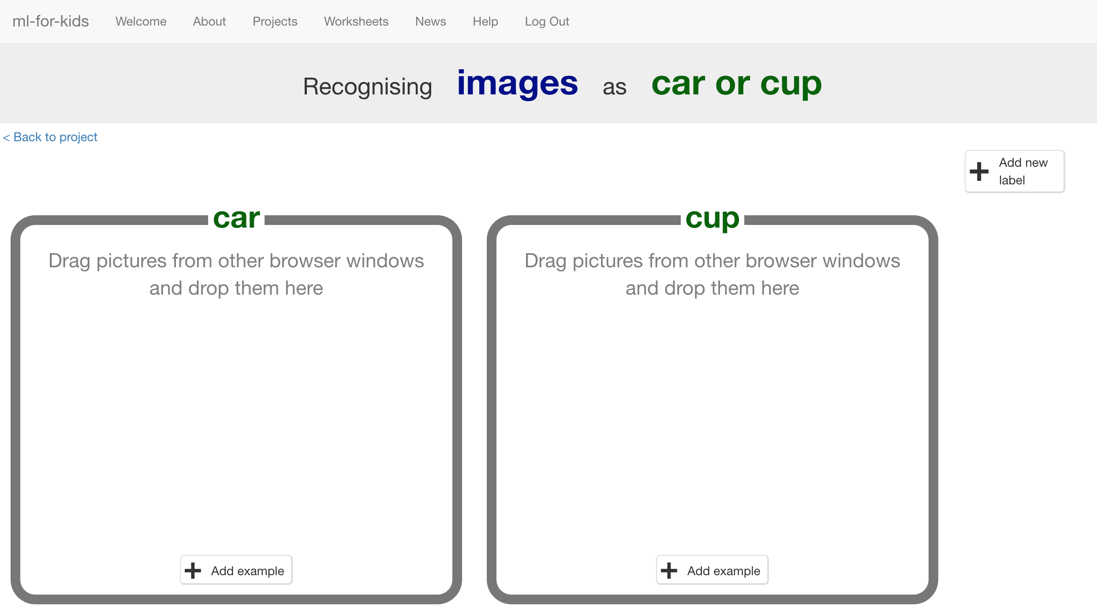

1. Open another web browser window.
2. Arrange the web browser windows so that they are side by side.  
   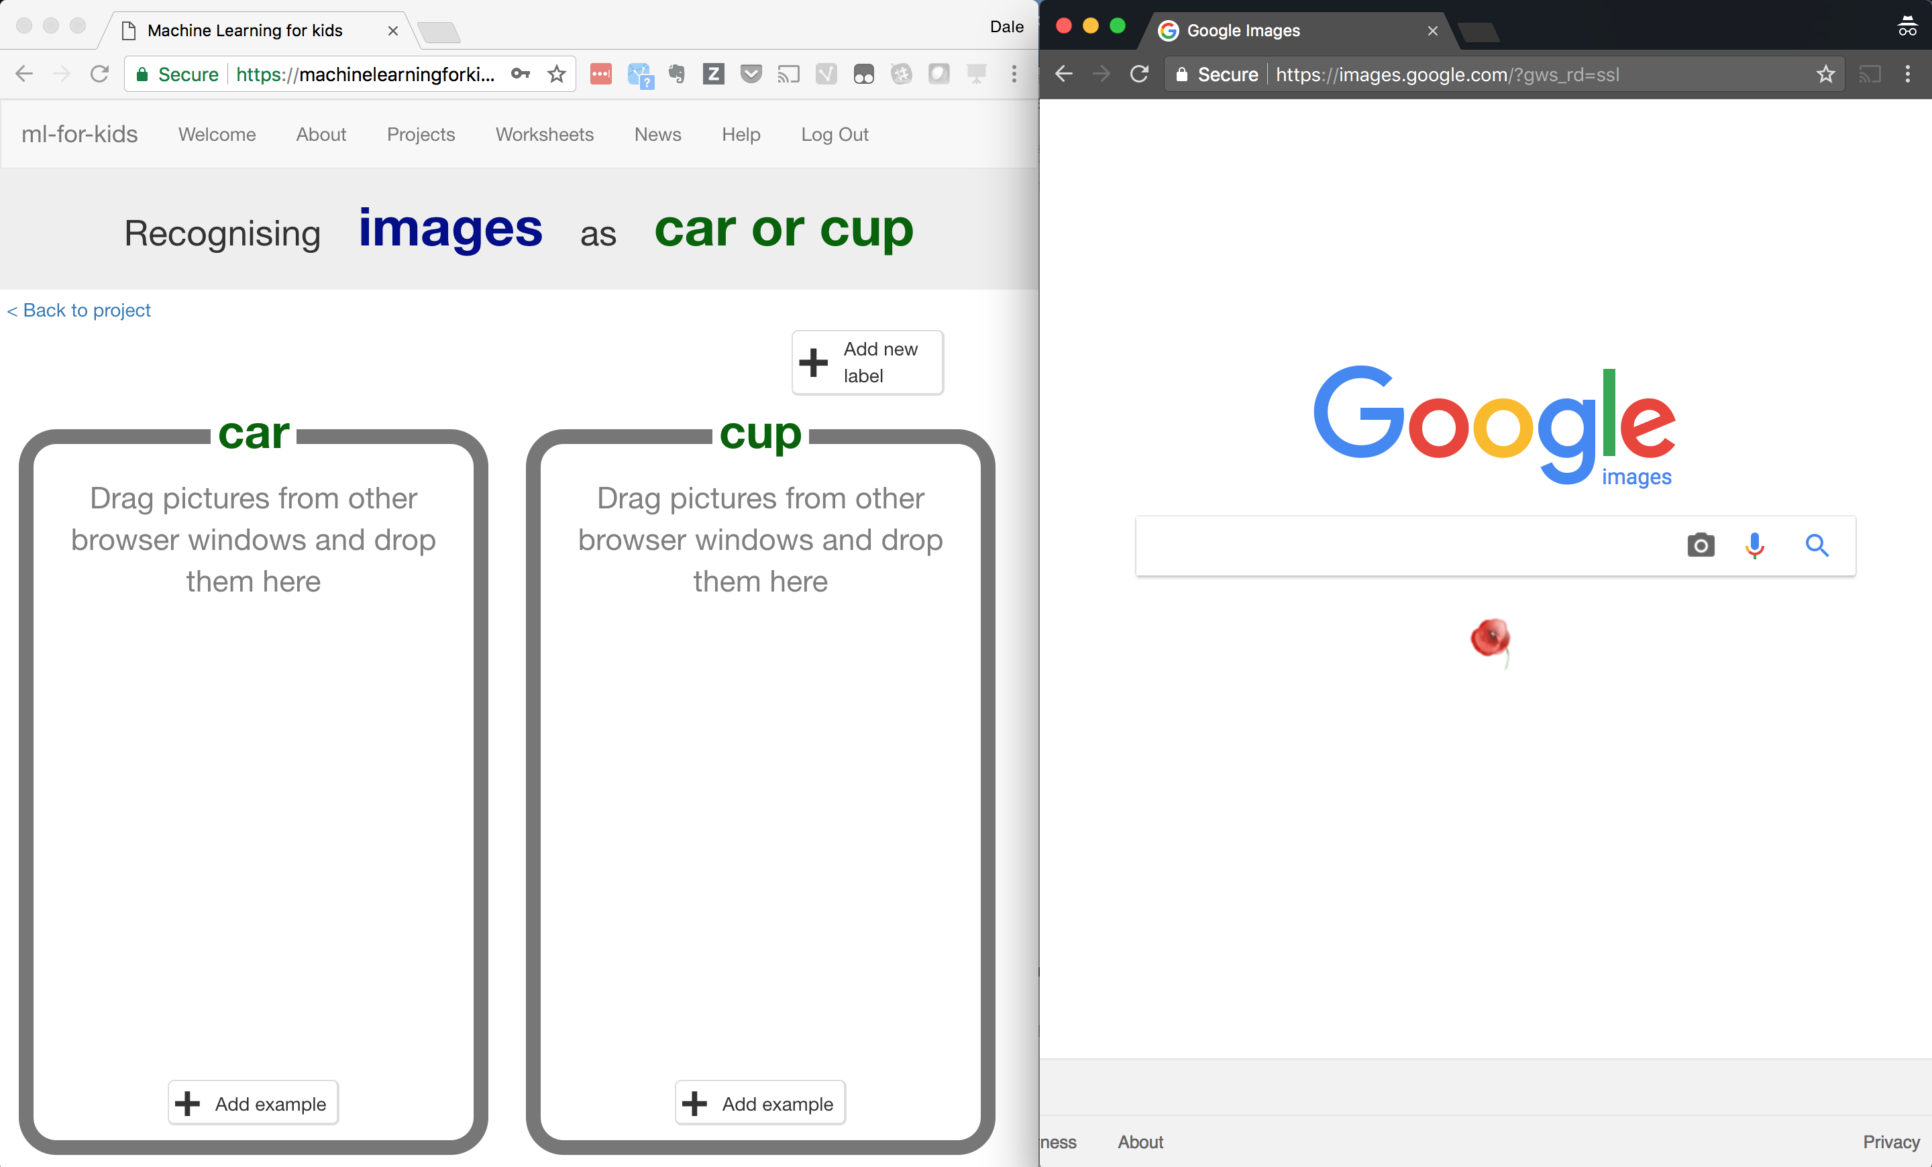
3. In the new browser window, search for pictures of cars.   
   Drag pictures that are good examples of a car into the left bucket.   
   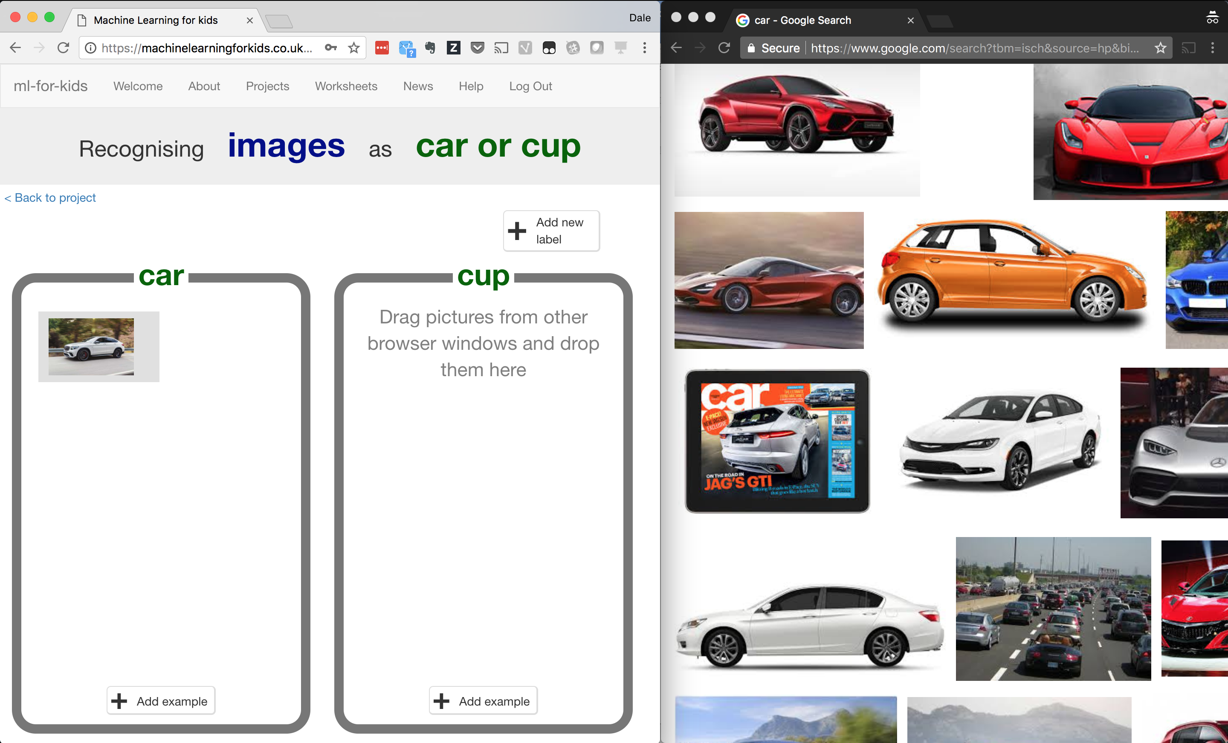
4. Repeat until you’ve got 10 examples of car photos.
5. Search for pictures of cups.   
   Drag pictures that are good examples of a cup into the right bucket.   
   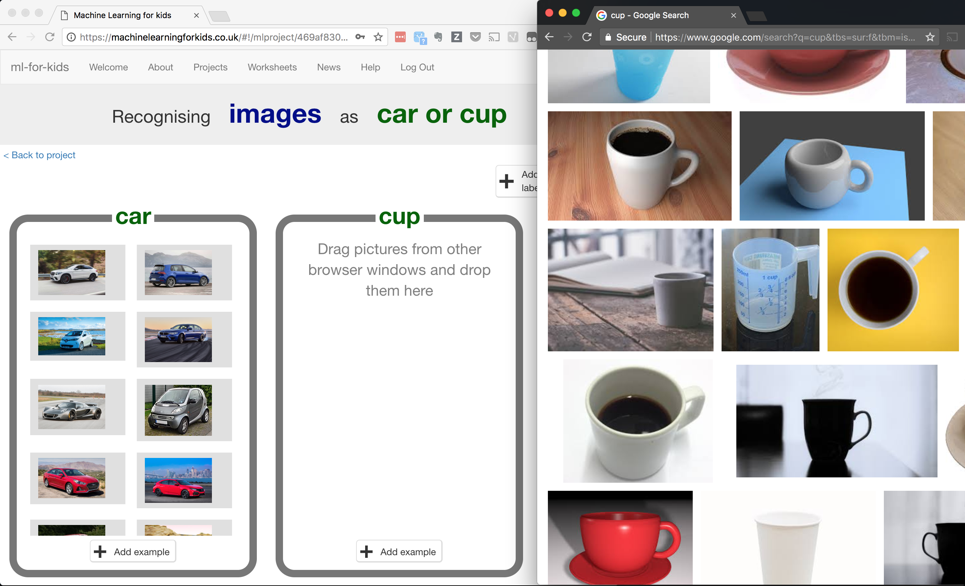
6. Repeat until you have 10 examples of cup photos.   
   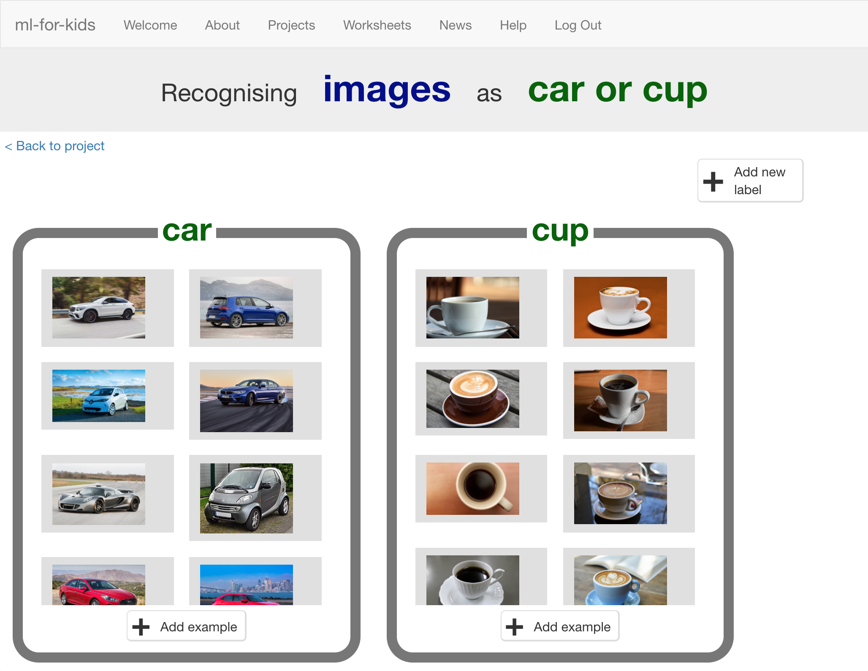
7. Click the “**< Back to project**” link.
8. Click the “**Learn & Test**” button
9. Click the “**Train new machine learning model**” button  
   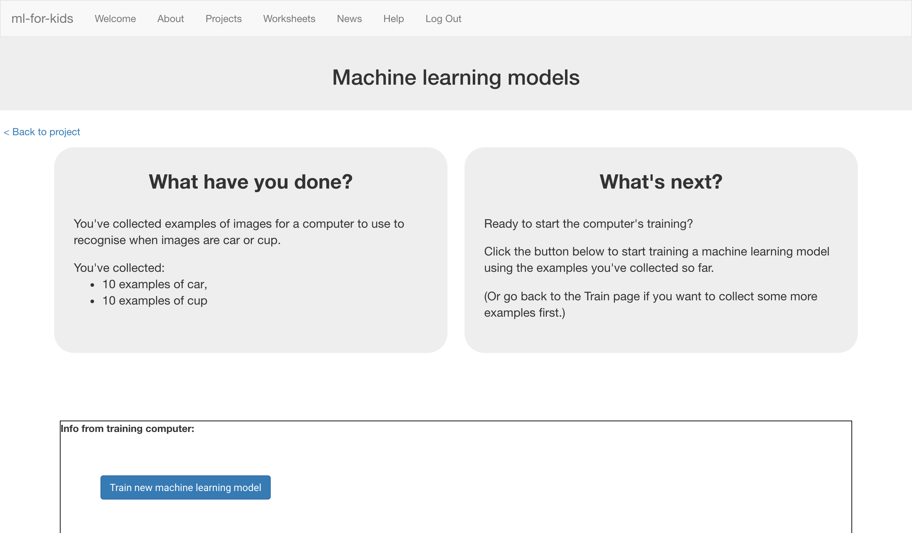
10. Wait for the training to complete. This might take a few minutes.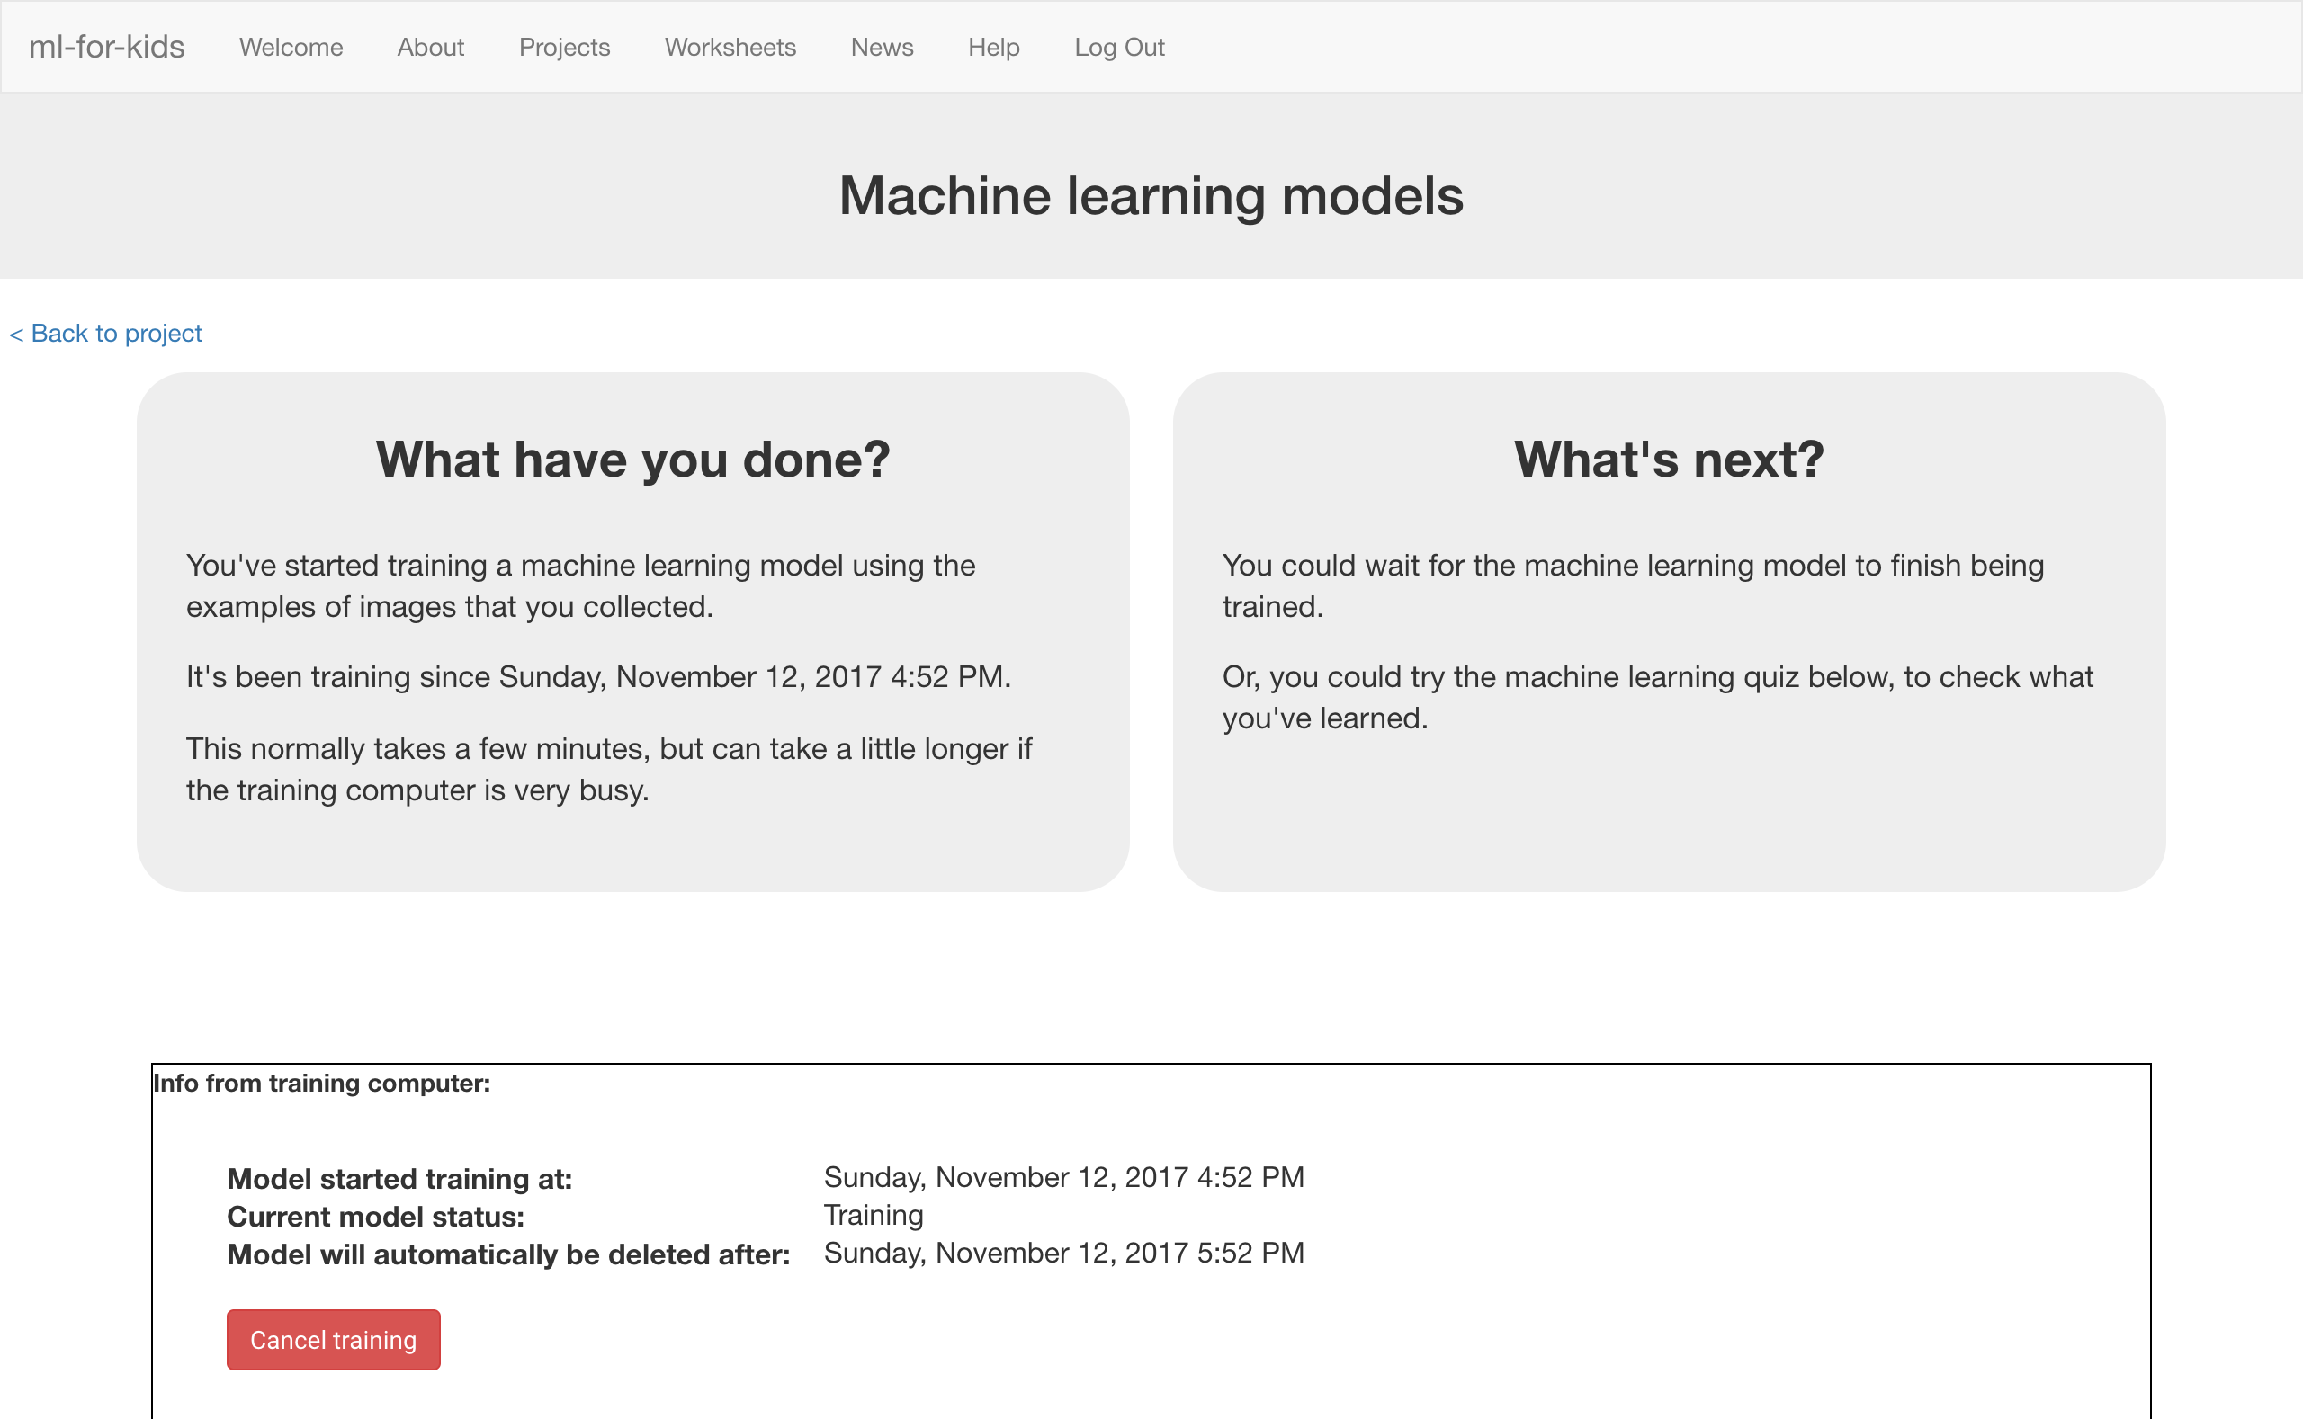

**What have you done so far?**

You’ve started to train a computer to recognise pictures of cups and cars. Instead of trying to write rules to be able to do this, you are doing it by collecting examples. These examples are being used to train a machine learning “model”.

This is called “supervised learning” because of the way you are supervising the computer’s training.

The computer will learn from patterns in the example photos you’ve chosen, such as the shapes and the use of colour. These will be used to be able to recognise new images.

1. Click the **“< Back to project**” link, then the “**Scratch**” button.   
   *This page has instructions on how to use the new blocks in Scratch.   
   Keep the page open if you need to check back on how to use them.*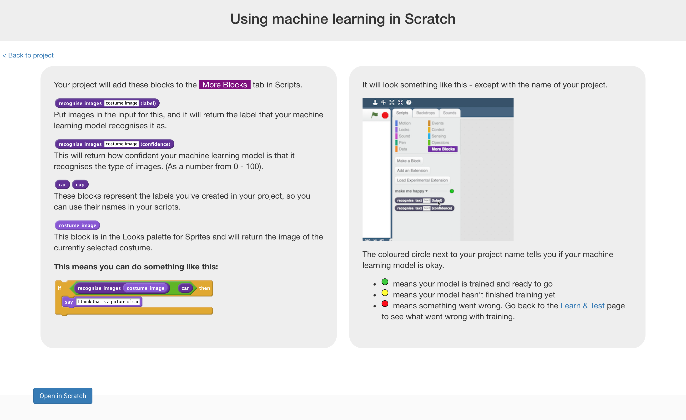
2. Click the “**Open in Scratch**” button to launch the Scratch editor.   
   *You should see new blocks in the “More blocks” section from your “car or cup” project.  
   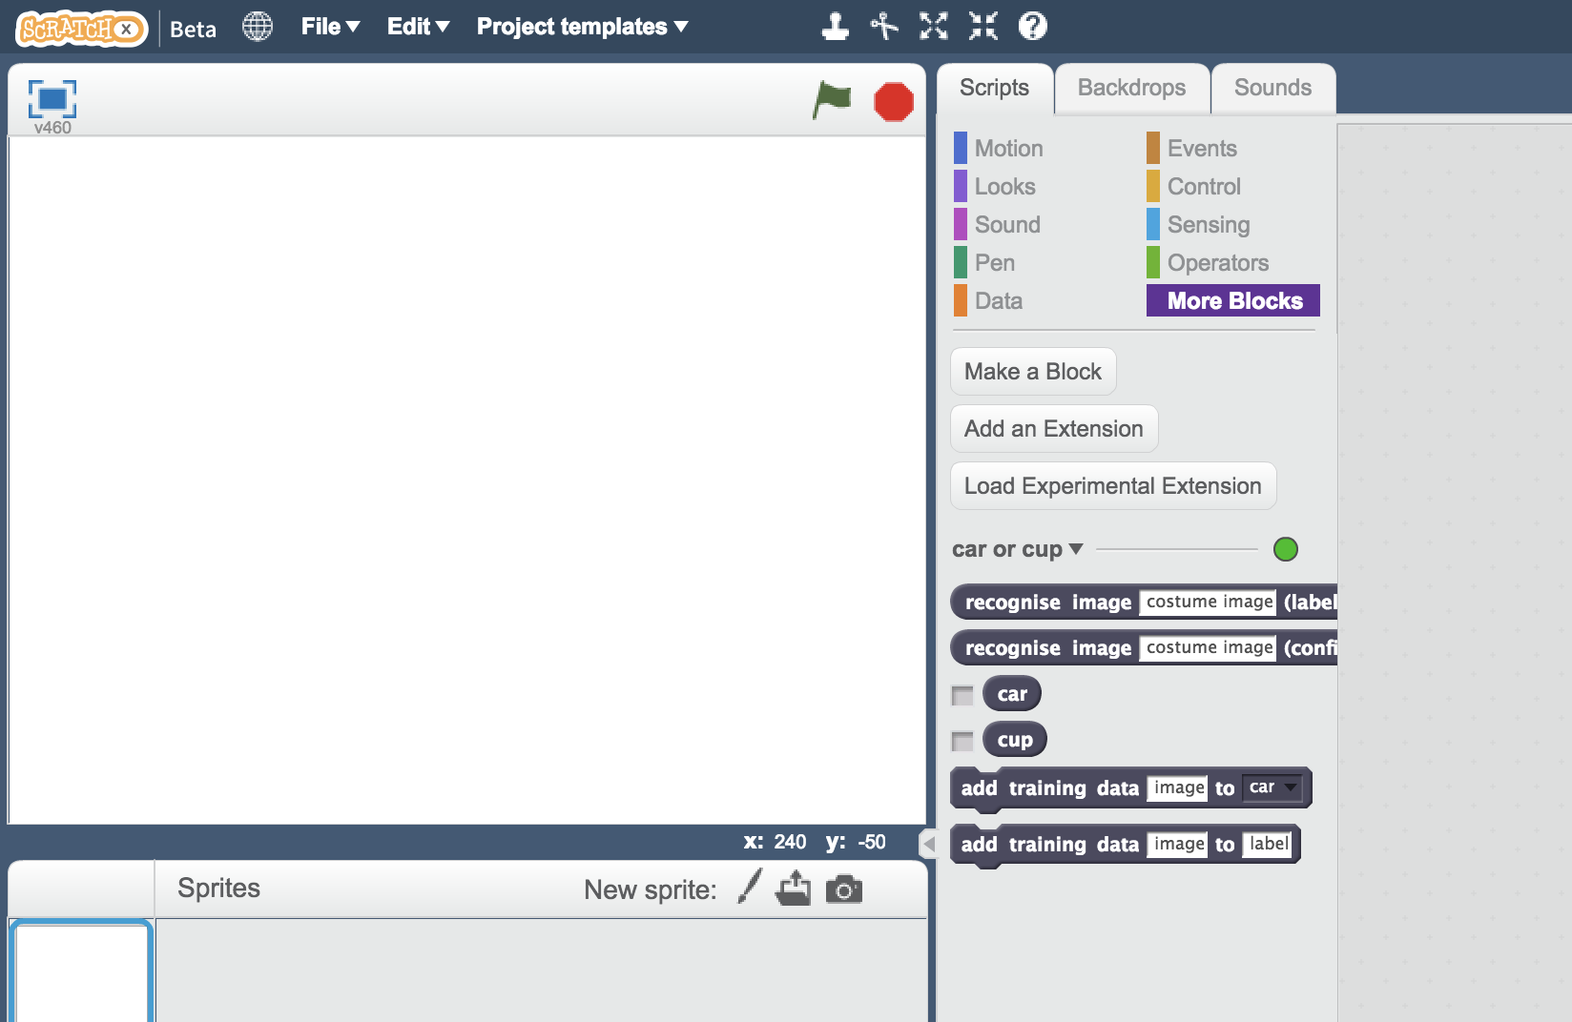*
3. Load the **Car or cup** template   
   *Use* ***Project templates*** *->* ***Car or cup*** *as shown below.*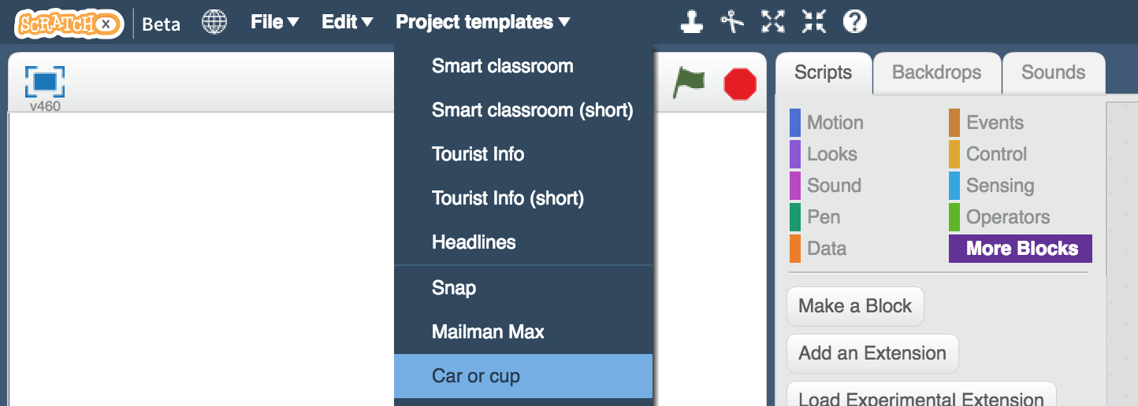

**Tips**

**More examples!**

The more examples you give it, the better the computer should get at recognising whether a photo is a cup or car.

**Try and be even**

Try and come up with roughly the same number of examples for cups and cars.

If you have a lot of examples for one type, and not the other, the computer might learn that type is more likely, so you’ll affect the way that it learns to recognise photos.

**Mix things up with your examples**

Try to come up with lots of different types of examples.

For example, make sure that you include some examples with different backgrounds.   
  
If every photo of a car you use for training has grass in the background, and every photo of a cup you use for training is on a wooden table, you might end up training the computer to recognise grass or wood instead.

1. Click the **green flag** to give it a try.  
   *The project has several random photos or cars or cups.   
   Next you will modify the project to use the training you’ve given the computer, so that it can sort these photos into two piles.* 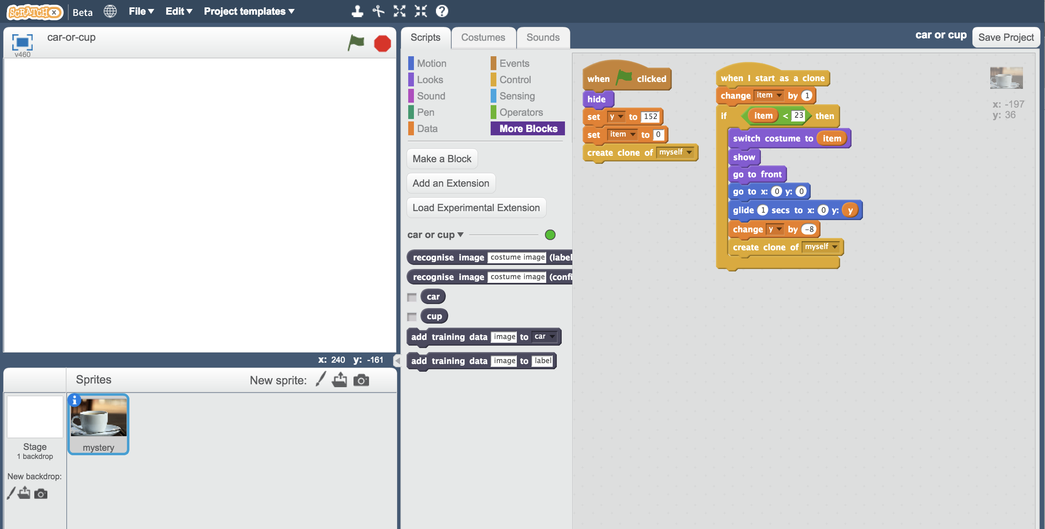
2. Click on the “mystery” sprite, and then click “**Scripts**” tab, and **change the script** to use your machine learning model.  
   *Start from the script that is already there, and change it to look like this.*   
   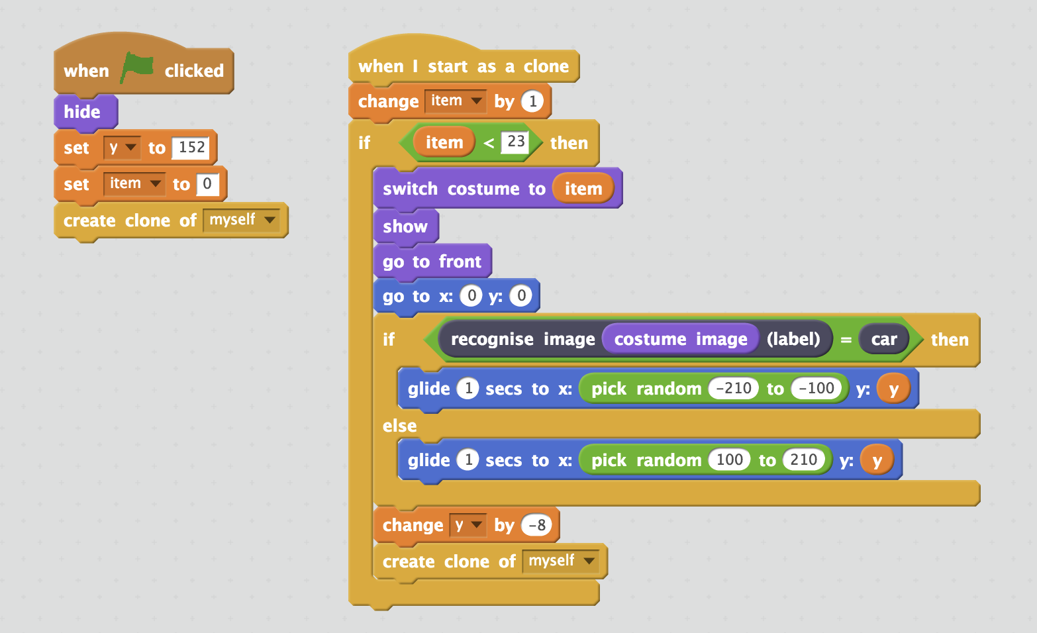
3. Click the full screen icon, and then click the green flag

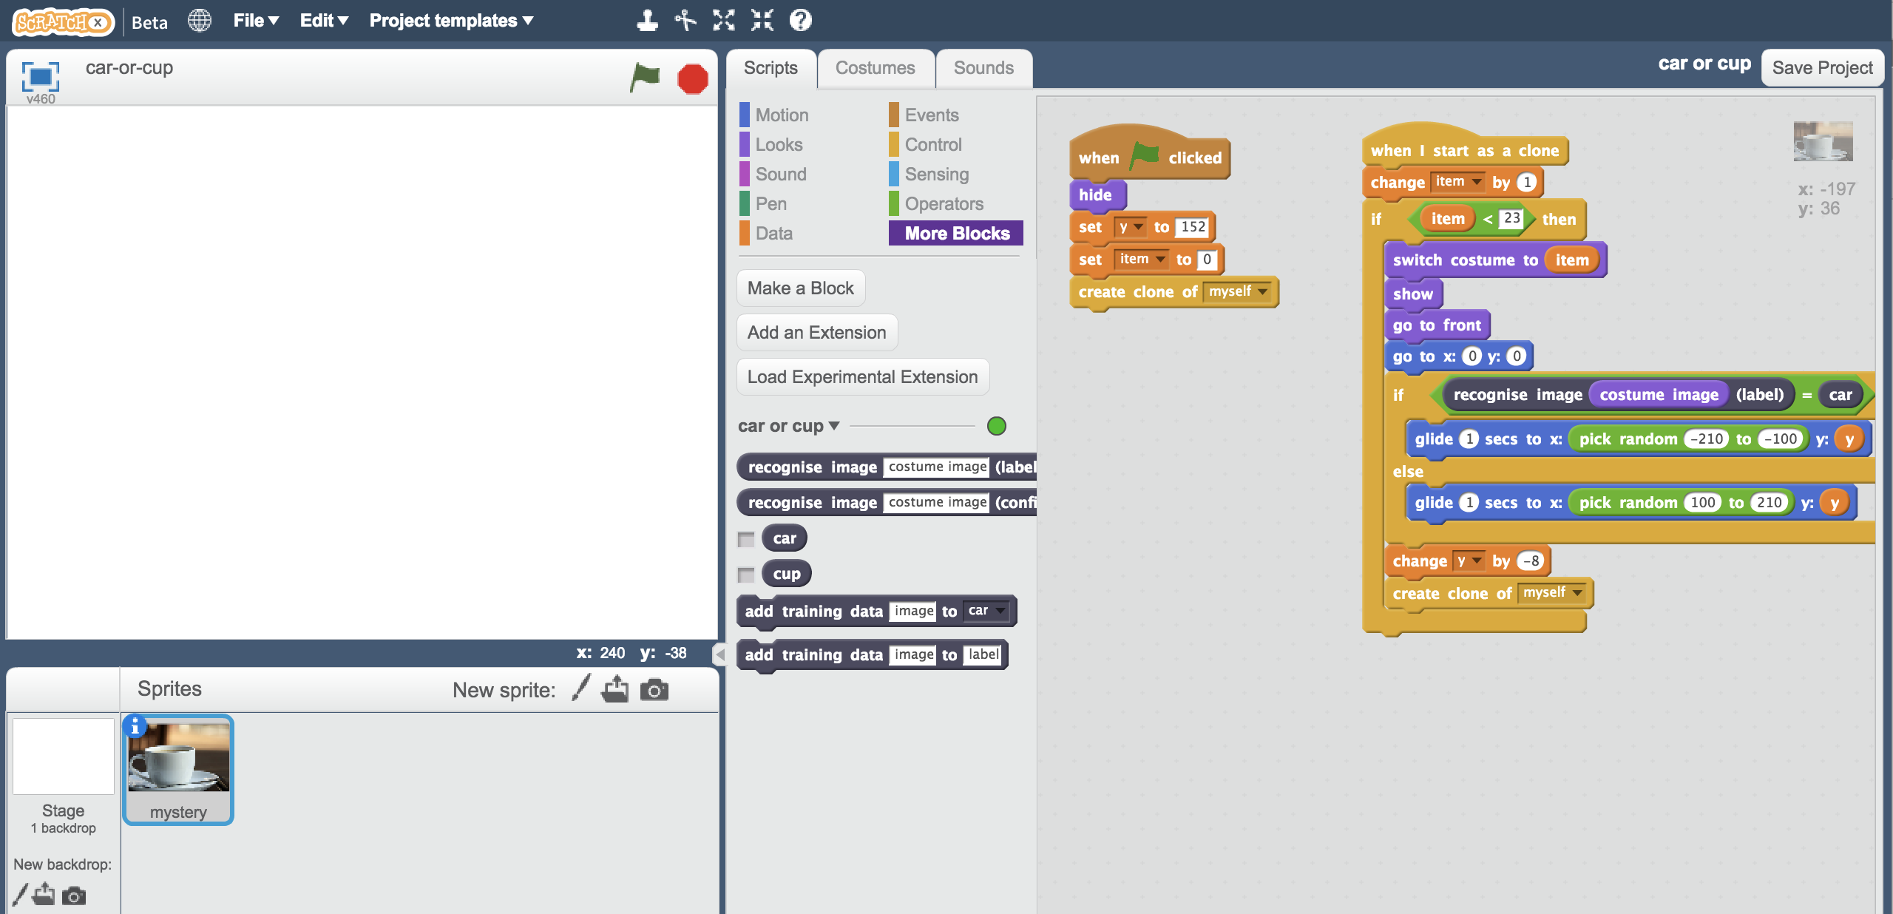

1. Watch your script use the machine learning model you’ve trained to sort the photos into two piles.   
   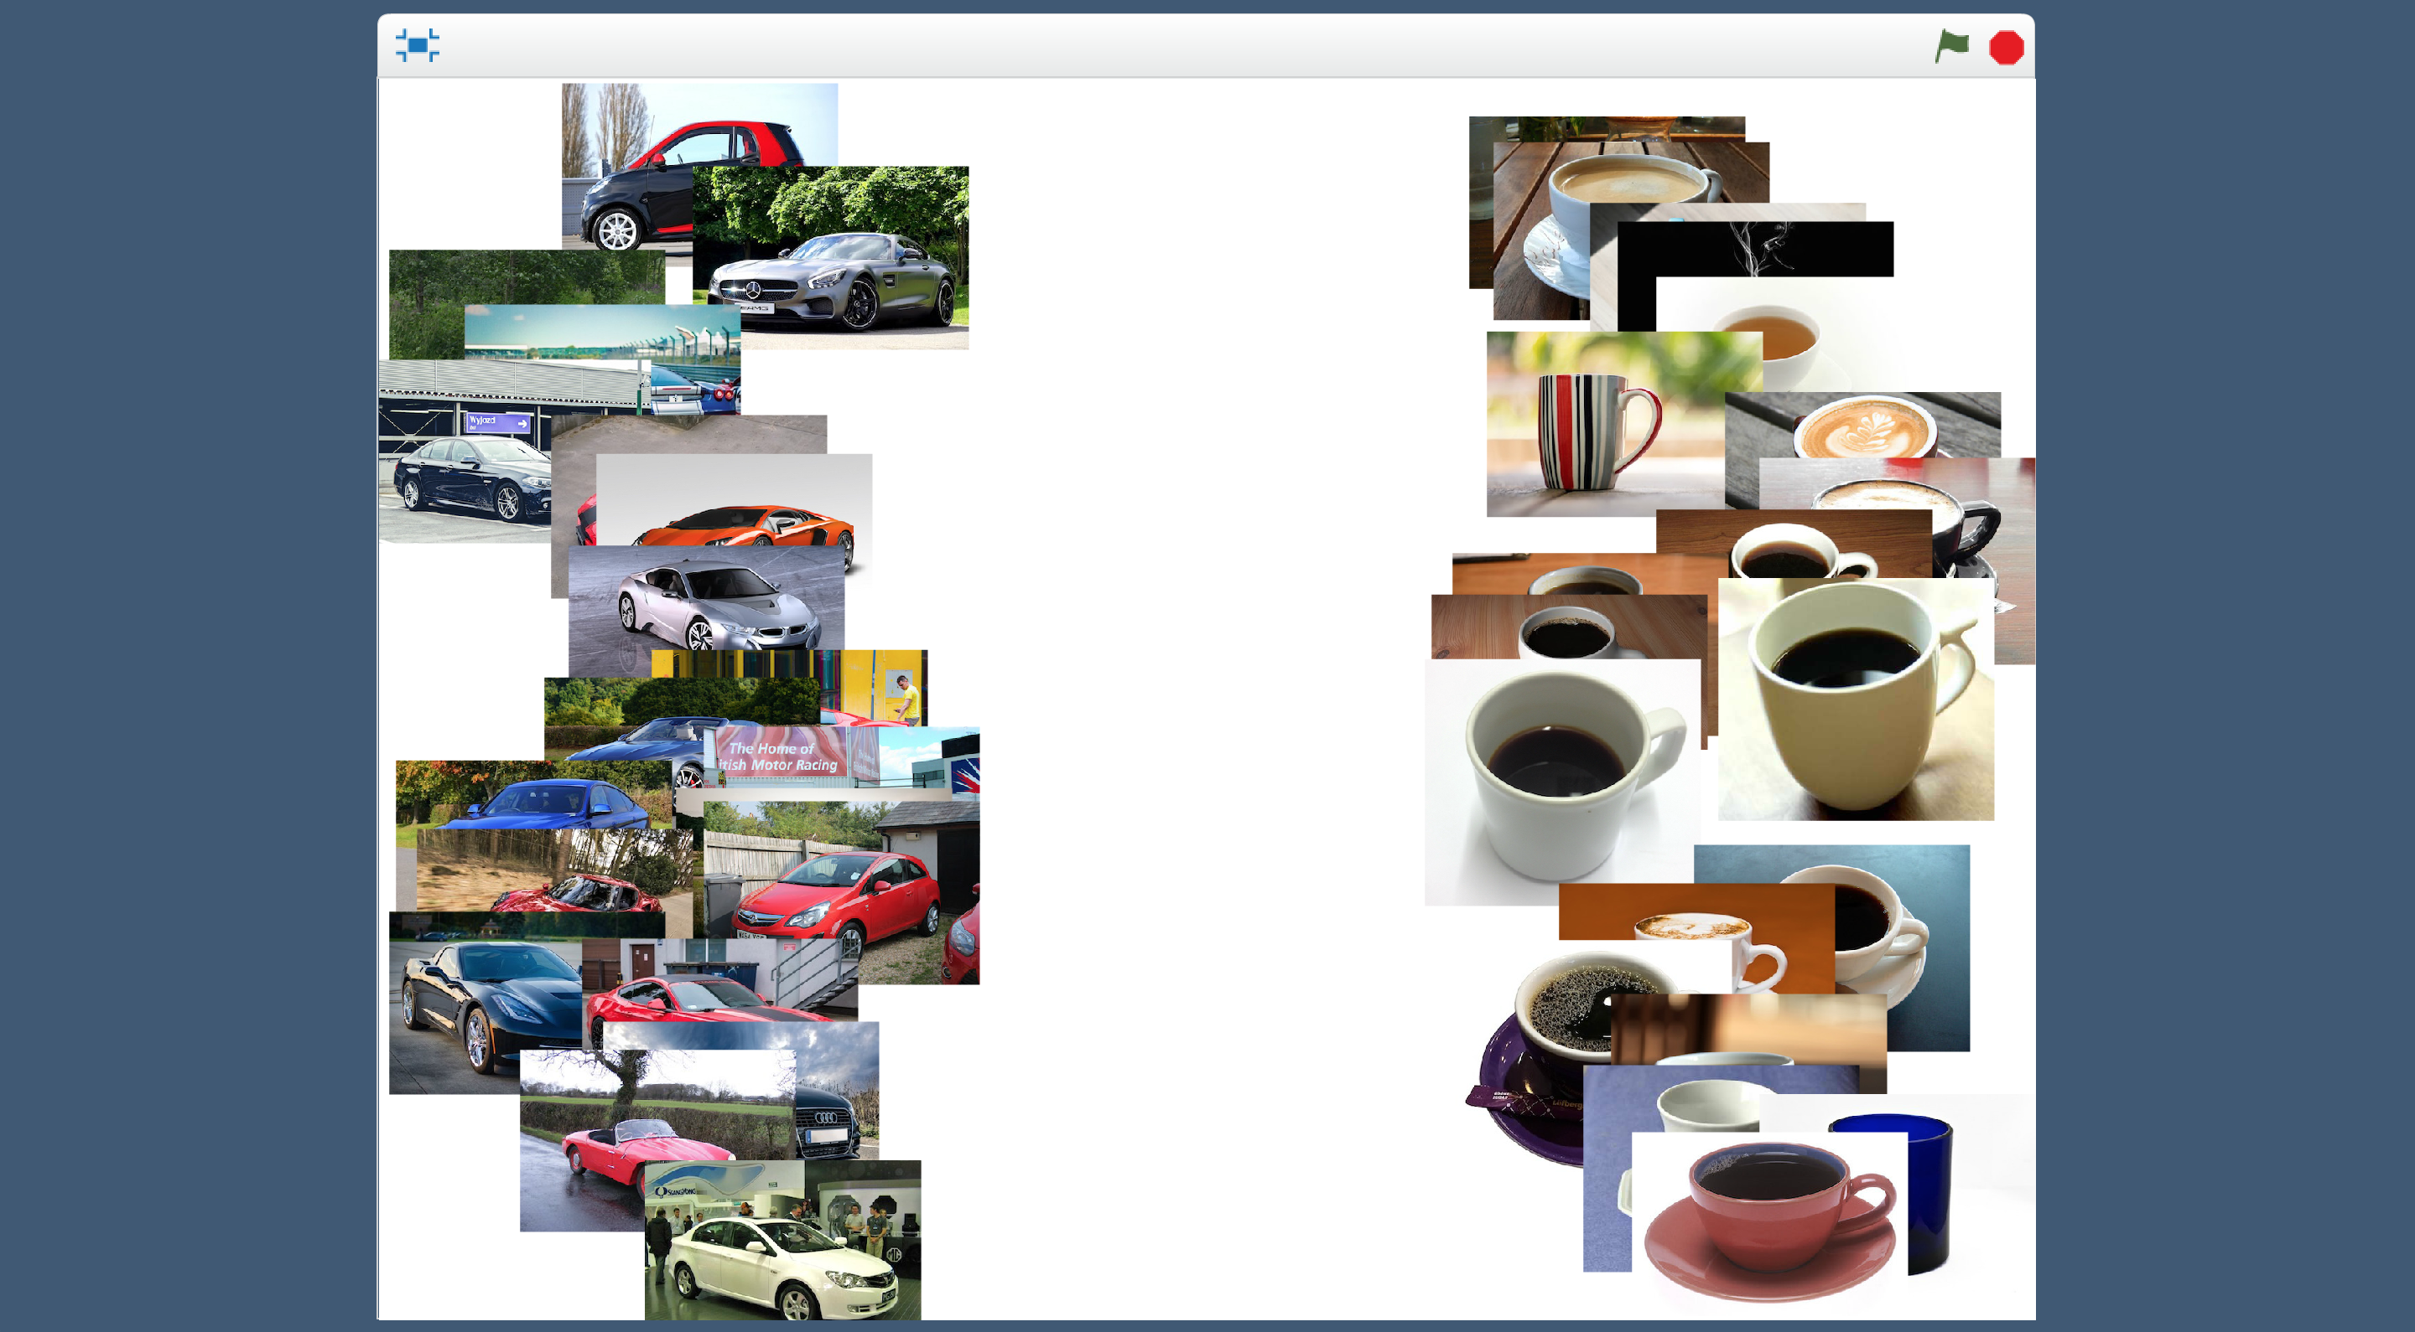
2. If your trained system makes mistakes, you’ll need to go back to step 14, and collect more examples.   
   *Make sure you repeat step 18 to train a new model with the extra examples that you’ve collected.*
3. Save your project.  
   *Click* ***File*** *->* ***Save project***

**What have you done?**

You’ve used machine learning to build an automatic photo sorter.

Training the computer to be able to recognise photos for itself is much much quicker than trying to sort thousands of photos manually.

And the more examples you give it, the better it should get at recognising photos correctly.

**Ideas and Extensions**

Now that you’ve finished, why not give one of these ideas a try?

Or come up with one of your own?

**Add a third type of photo**

Instead of just recognising cups and cars, can you add a third type as well?

**Try confusing the computer**

Train the computer to recognise cars with ten photos of a car on a grass background.

Train the computer to recognise cups with ten photos of a cup on a plain white background.

Now see if the computer recognises a car on a plain white background.

Or if it can recognise a cup on a grass background.

Does the computer get confused? Did it learn to recognise the cup and car? Or was it more influenced by the background?

Experiment to find out how the computer learns, and how it behaves.